## Update on Improved Internet Service at Diamond Cove

June 30, 2014

Over the last 18 months we have pursued a number of different options trying to get improved internet service to Diamond Cove. During that time, we worked with, and received a proposal from Fairpoint to upgrade the service from a current speed of ~ 1megbytes per sec (Mbps) to something around 5-7 Mbps (download). It took 3 months of work and meetings to get this proposal that turned out to be unworkable since Fairpoint required a guaranteed payment from the DCHA of almost $200k over 2 years. We also tried to get Time Warner Cable to come to the island for both TV and high speed internet. After some prodding and follow-up, they declined to investigate any further. During last fall and winter we had multiple meetings with 3 separate internet providers on the island who already provide internet in the state. None could offer any viable solution that would not cost a significant amount of money for the DCHA.

One company (Redzone Wireless) recently began to offer high speed internet in the Portland market using a unique frequency spectrum to transmit the signal to homes and businesses that had a direct line of sight to their tower on top of One City Center in downtown Portland. (no cable/direct connection needed) RedZone currently offers high speed internet to approximately 800 homes in Maine- usually more rural locations. With clear line of sight, the signal can carry up to 5 miles with no loss in strength. The Redzone engineers climbed our water tower at Diamond Cove and determined that we have clear line of sight from there to One City Center. Once the signal is received at DC, it would be re-transmitted to homes requesting the service. As you can see from their website, ([www.Redzonewireless](http://www.Redzonewireless)) RedZone offers 4 packages with speeds of up to 50 Mbps which would offer significant improvement on the island. We feel that at the present time, RedZone offers the best opportunity for improving service to DC and we are working with them on a proposal.

We have also started working with a ME state organization called ConnectME that provides subsidies to communities that are unserved or under-served in terms of broadband speed in the state. ConnectME has a competitive proposal system that can provide up to 50-60% of the capital needed for a community project. Today, DCHA and RedZone submitted an application for the DC project that would (if we are successful) pay $44k of the $75k that would be necessary to complete the project within our community. The remainder would be a possible capital project approved by the board that we feel would enhance the attractiveness of our community and provide a real service to our residents. We should know within approximately one month if we have won a grant and also if Fairpoint would challenge the grant (which they have a right to do) which could delay or mitigate the award.

From a board perspective, we are considering the alternatives in the event we do not win the grant. At this point, we see no other viable option other than RedZone. Without a grant, the cost to the community would be approx $70-75k. There are a number of residents and board members who feel passionately that we need a better internet solution or risk becoming a second class destination and community which would affect re-sale and rentals values as well. However, the board is also wrestling with how best to divide up the cost of the project if we do not win the ConnectME grant. We believe that some combination of DCHA subsidy and one time sign up fees for individuals who want the service may be the fairest way to generate the needed capital. However, before proceeding, we would like to get feedback from the community via a survey.

The results of the survey will be used to gauge the need within DC for better internet coverage and, assuming ConnectME funds are not available, the amount people are willing to pay as a onetime sign up fee. This survey is only a few questions long, and your response/participation would be greatly appreciated.

If you have any further questions, please feel free to email me at [MatthewHoffner@gmail.com](mailto:MatthewHoffner@gmail.com).

Thanks

Matt Hoffner

DCHA Board President

UPDATE August 7, 2014

The saga continues…

Earlier this month, we were informed that we in fact won the ConnectME grant for the full amount we requested. We were one of only a handful of grants that were awarded funds.

Unfortunately, Fairpoint, who is at risk of losing much of their business at DC has decided to contest the award. They have filed a statement with their protest that indicates they currently supply adequate internet speed and reliability to the DC community. (always greater than 1.5meg download speed)

The next step in the process is for us to defend our grant request in front of the ConnectME board that will be meeting in September. In order to bolster our case, I need data from our community members showing the internet speed at your house.

If you would, please take a moment to log onto [www.speedtest.net](http://www.speedtest.net) when you are on the Fairpoint DSL at DC. Once there, click on “Begin Test” At the end of the test (takes about 30 secs), you will see this box and you can click on “Share Results” (obviously this test example was done from my office and NOT from the island showing 7.36Mbps download)

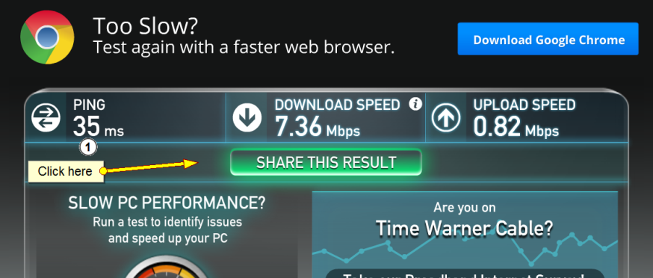

Once you click on “Share Results”, you will see this screen where you can click on “Copy” and then paste the link into an email to me at [MatthewHoffner@gmail.com](mailto:MatthewHoffner@gmail.com).

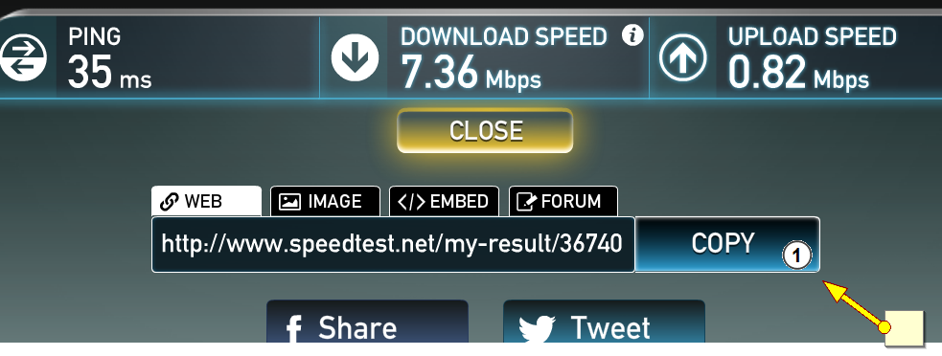

Obviously, we believe that a vast majority of the results will be below 1.5 Mbps (Download), but I need your test results to share with the ConnectME board. The results will NOT show your name, only the date and time of the test.

Thank you for your help.

Matt Hoffner

DCHA President